Database systems

Lab 1

Hassaan Akbar Cheema

174351

# Lab Task

1. Retrieve names of movies starting with S.

Query:

select title from film where title like 'S%';

Result:

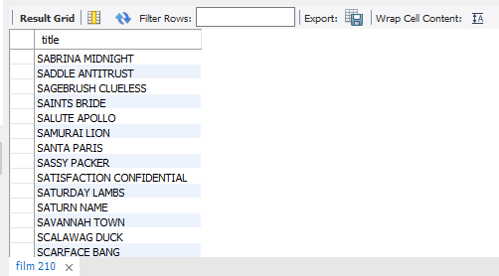

1. Select release year of movies starting with M?

Query:

select release_year from film where title like 'm%';

Result:

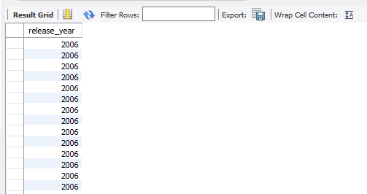

1. Retrieve data of all actors whose names are not ending on T.

Query:

select actor_id,first_name,last_name,last_update from actor where last_name not like '%t';

Result:

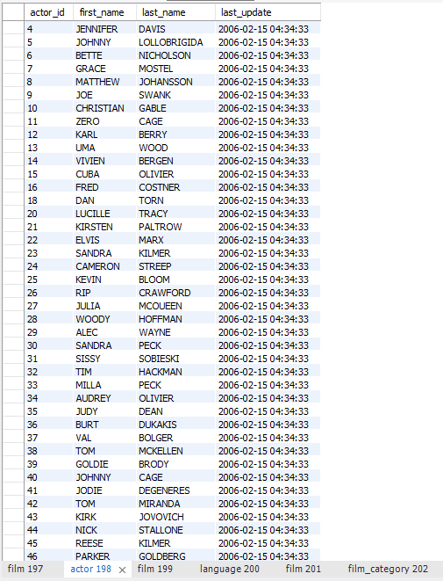

1. List languages for movie Alone Trip.

Query:

select language_id from film where title like 'alone trip';

select name from language where language_id = 1;

Result:

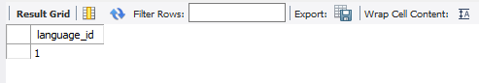

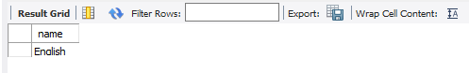

1. What category does the movie ADAPTATION HOLES belong to?

Query:

select film_id from film where title like 'ADAPTATION HOLES';

select category_id from film_category where film_id = 3;

select name from category where category_id = 6;

Result:

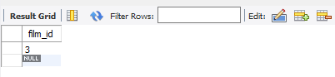

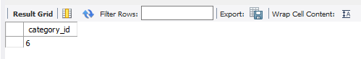

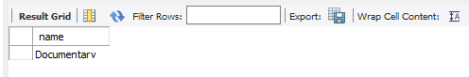

1. Retrieve first and last name of actors who played in ALONE TRIP.

Query:

select film_id from film where title like 'alone trip';

select actor_id from film_actor where film_id = 17 ;

select first_name,last_name from actor where actor_id = 3 or actor_id = 12 or actor_id = 13

or actor_id = 82 or actor_id = 100 or actor_id = 160 or actor_id = 167 or actor_id = 187;

Result:

